Tursynbay Mansur CS - 2428
Bootcamp Web Risks
The homepage of a company called "Heavy Logistics" is displayed on a web browser (fig.3.41). The company deals with city logistics and transport management. The website address shown at the top of the browser is 10.124.1.235.

Fig. 3.41 Web page

Exploring a Server for Hidden Directories
There are results of a command used to explore a server with the address http://10.124.1.235/. This command is like a detective tool that searches for hidden files and folders on a website.
During the search, the tool found several directories (folders) and files. Here are some important parts:
- The tool found many hidden files that start with a dot (e.g., .htaccess, .php). These files are often used for server configuration and are usually hidden from normal users.
- It found a directory named /api and confirmed it is located at http://10.124.1.235/api/.
- It also found another directory called /assets at http://10.124.1.235/assets/.
These findings indicate that the server has special sections and files that might be important for managing the website or providing specific services (fig.3.42).
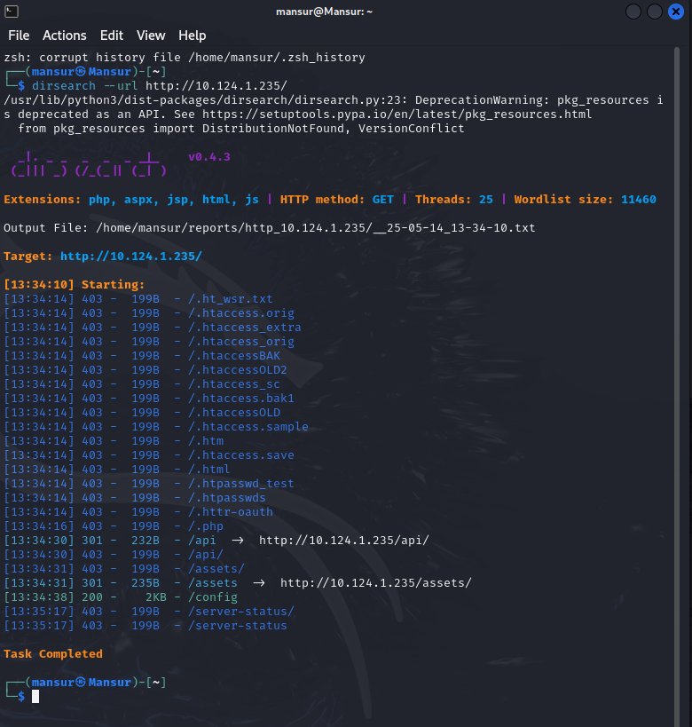
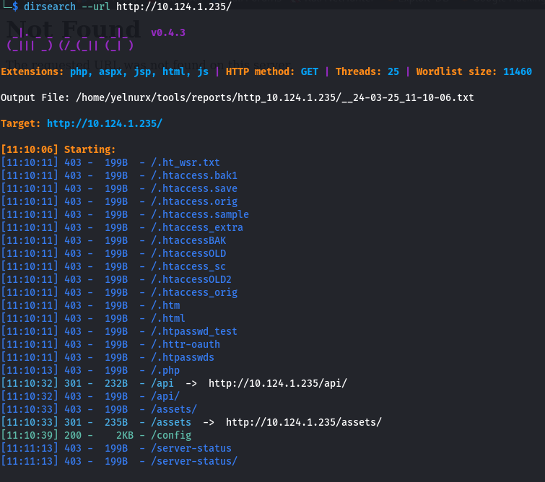
Fig. 3.42 Foung directory /api on 10.124.1.235
The results of a tool called Gobuster being used to search for hidden files on a server at the address http://10.124.1.235/api/. Gobuster helps find files and directories that are not easily visible.
Here’s Gobuster tells us:
- The search targeted the directory /api on the server.
- The tool used 10 threads to speed up the search.
- It used a list of common filenames to check against the server.
- It looked for files with the extension .php.
During the search, Gobuster found several hidden files. Here are some important ones:
- Files starting with a dot (e.g., .hta, .htaccess) are usually hidden and contain configuration settings. These files returned a status code 403, meaning access is forbidden.
- The file /read.php was found and returned a status code 200, meaning it is accessible and could be viewed or interacted with.
The caption Fig. 3.32 Found /api/read.php on 10.124.1.235 indicates that the /read.php file was successfully found and is accessible on the server at the specified address. 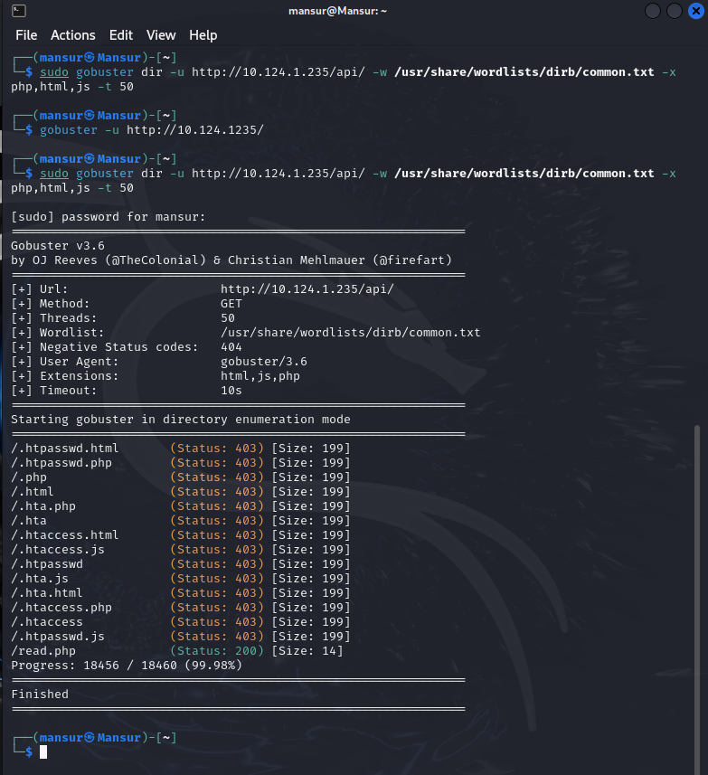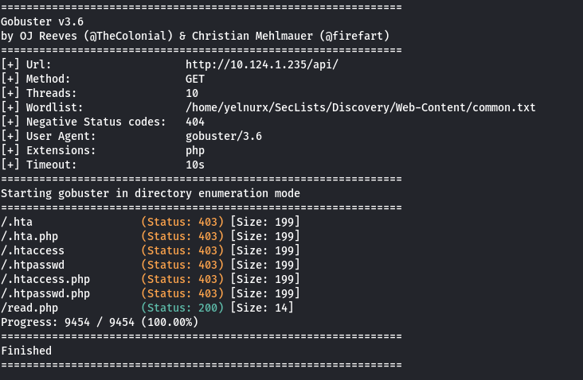
Fig. 3.43 Foung /api/read.php on 10.124.1.235

Finding Hidden Parameters on a Server
Here ffuf (Fuzz Faster U Fool) being used to search for hidden parameters on a server at the address http://10.124.1.235/api/read.php. Fuzz Faster U Fool helps find specific input options that a file or script on a server can accept.
Image below tells:
- The search targeted the URL http://10.124.1.235/api/read.php.
- The tool tried different possibilities by adding ?FUZZ to the end of the URL, where FUZZ represents various guesses.
- The search used a list of common parameters from a file to check against the server.
During the search, ffuf found a parameter called file. This means that the script read.php can take a parameter called file, which might be used to specify a particular file to read.
The caption Fig. 3.33 Found parameter /api/read.php?file= on 10.124.1.235 indicates that the file parameter was successfully found and can be used with read.php on the server at the specified address. 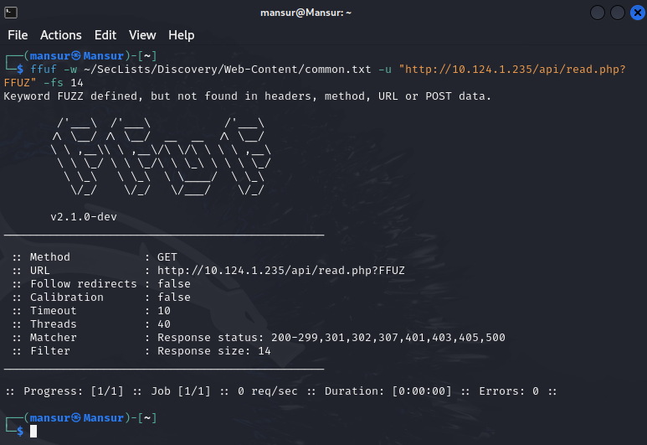
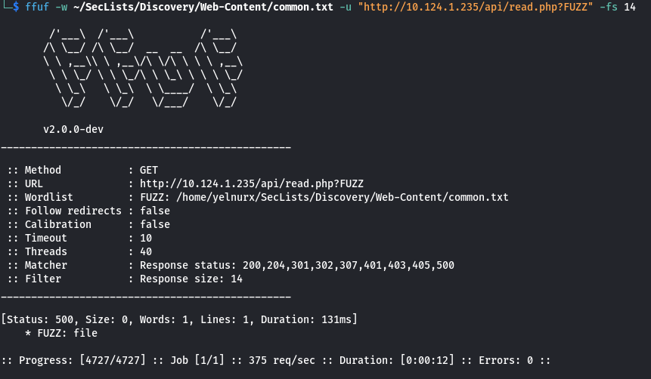
Fig. 3.43 Found parameter /api/read.php?file= on 10.124.1.235

Local File Inclusion on a Server
The image shows what happens when a special trick called Local File Inclusion (LFI) is used on a server. LFI is a way to make a website show files from its own system, which are normally hidden.
Here’s what the image tells us:
- Address Bar: At the top, we see the web address http://10.124.1.235/api/read.php?file=/etc/passwd. This means someone used the read.php script on the server and asked it to show the contents of a specific file: /etc/passwd.
- File Content: Below the address, we see a lot of text. This text is the content of the /etc/passwd file from the server. The /etc/passwd file on a server contains information about all the user accounts on that system. It lists usernames, user IDs, and other details.
- Caption: The caption Fig. 3.34 Local File Inclusion on http://10.1.124.235/api/read.php?file=/etc/passwd explains that this trick was used to make the server show the /etc/passwd file.
Explanation:
In simple terms, Local File Inclusion is like tricking a website into showing secret files from its computer. In this case, someone tricked the server into showing a list of all its user accounts by using the read.php script and specifying the /etc/passwd file.
It's important to note that not only the /etc/passwd file can be accessed using this method. Any file that the server has permission to read could potentially be accessed this way, making it a serious security issue. For example, configuration files, log files, or other sensitive documents could also be revealed. 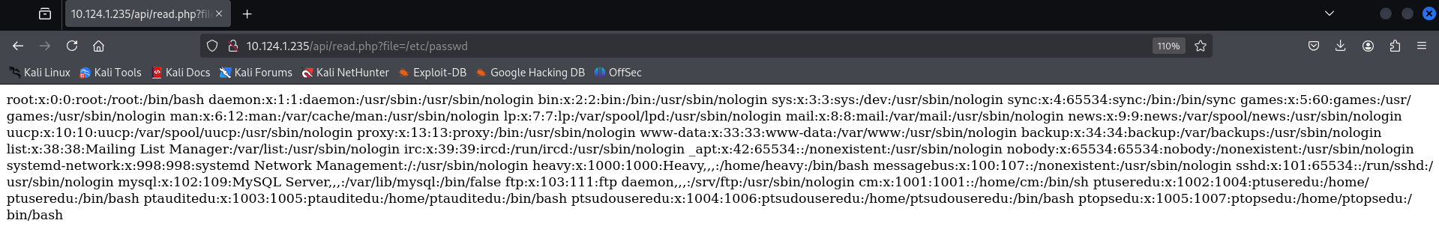
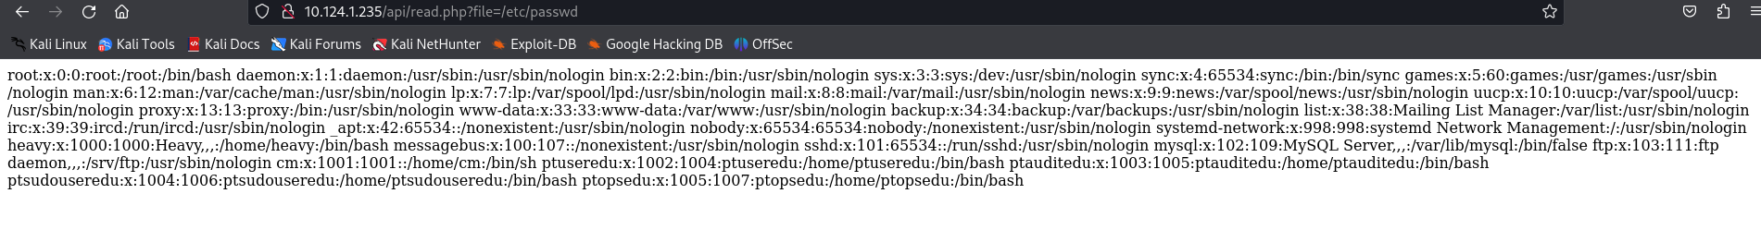
Fig. 3.44 Local File Inclusion on http://10.1.124.235/api/read.php?file=/etc/passwd
By exploiting Local File Inclusion, the person was able to read the pt.flag file, which is located at the default path /etc/pt.flag. In this context, a "flag" file typically contains important information or a secret code used in security challenges and hacking competitions.
This example highlights the potential vulnerabilities of LFI, demonstrating how it can be used to access not only common system files but also specific and sensitive files like pt.flag. It underscores the importance of securing web applications against such exploits.
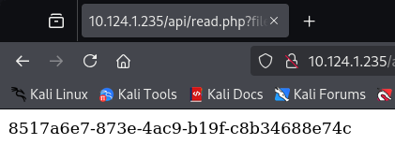
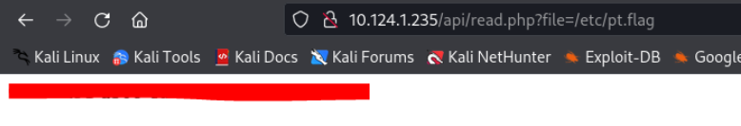
Fig. 3.45 Reading the flag from LFI

Generating a PHP Filter Chain
Process called PHP filter chain generating, which involves creating a sequence of commands to manipulate data in a PHP script.
- Command Used: The command python3 php_filter_chain_generator.py --chain '<?=$_GET[0]?>' is run in the terminal. This command uses a Python script to generate a special PHP code.
- Generated Code: The output shows a long list of commands that will be executed in sequence. These commands are used to decode and encode data in different ways.
Explanation:
The purpose of this process is to generate a PHP code snippet that can process data through multiple filters. Here’s what’s happening:
- PHP Code: The code <?=$_GET[0]?> is a PHP script that takes input from a URL parameter. In PHP, $_GET[0] means it’s looking for the first parameter in the URL.
- Filter Chain: The generated filter chain is a series of commands that encode and decode the input data in various formats. For example, it might convert data from one character encoding to another, or encode it in base64 format.
Usage:
This kind of filter chain is often used in security testing to see how well a web application handles different types of data processing. It can also be used to exploit vulnerabilities if the application does not properly sanitize inputs.
The caption Fig. 3.36 PHP filter chain generating indicates that this image shows the process of creating a filter chain using PHP.
The tool used for generating the PHP filter chain can be found on GitHub at the following address: PHP Filter Chain Generator on GitHub. This repository provides a script that helps generate PHP filters chain, enabling remote code execution without needing to upload a file if you control the parameter passed to a require or include statement in PHP. 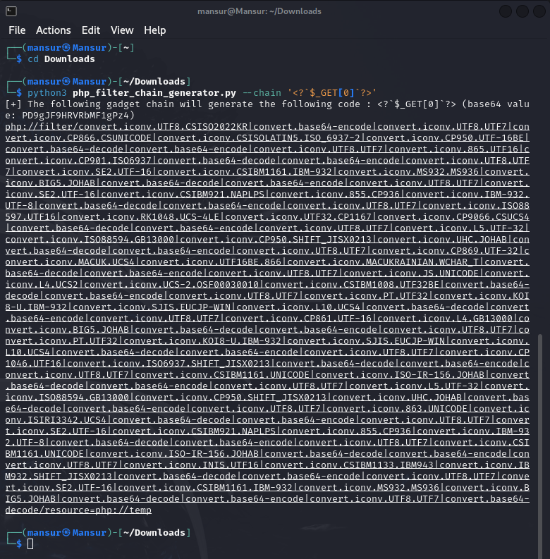
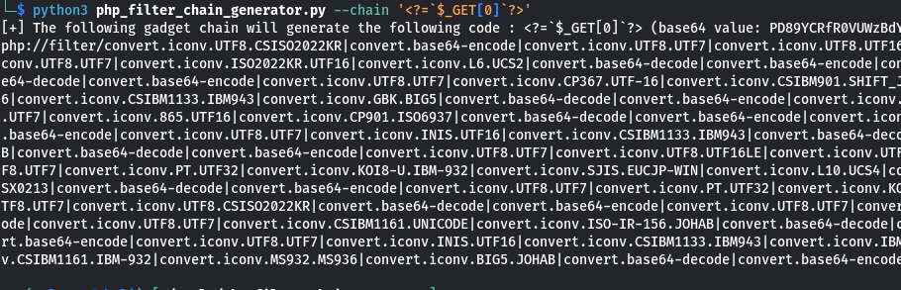
Fig. 3.46 PHP filter chain generating

Remote Code Execution with PHP Filter Chain
There was demonstrated how Remote Code Execution (RCE) can be achieved through Local File Inclusion (LFI) by using a PHP filter chain.
- Address Bar: The web address http://10.124.1.235/api/read.php?file=php://filter/convert.iconv.UTF8.CSISO2022KR|convert…&0=id shows that someone has used the read.php script on the server with a special filter chain command.
- Command Output: The result displayed is uid=33(www-data) gid=33(www-data) groups=33(www-data), which indicates that a command has been executed on the server. This output shows the user ID, group ID, and group name of the web server user.
Explanation:
Remote Code Execution is a powerful and dangerous capability where an attacker can run commands on a remote server. Here's how it works in this example:
- Local File Inclusion (LFI): The attacker uses the read.php script to include files on the server.
- PHP Filter Chain: By using a series of PHP filters, the attacker converts the input data in a way that allows code execution. The filter chain in the URL manipulates the input data to run commands.
In this case, the attacker successfully used the filter chain to execute a command that displays the user information for the web server user (www-data). This demonstrates a severe security vulnerability, as the attacker can potentially run any command on the server.
The caption Fig. 3.37 Remote code execution from LFI with PHP filter chain explains that this image shows the result of executing commands on the server by exploiting LFI and using a PHP filter chain. 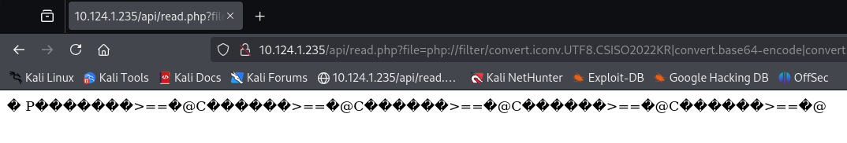
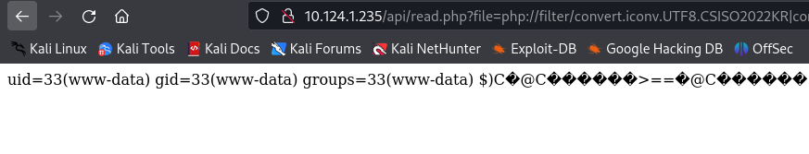
Fig. 3.47 Remote code execution from LFI with php filter chain

Generating a Reverse Shell Payload
Reverse Shell Generator is a tool used to create a special command called a reverse shell payload.
- IP & Port: The tool allows the user to input an IP address and port number. These details tell the payload where to connect back to.
- Listener: A listener is set up using the command nc -lvnp, which listens for incoming connections from the reverse shell.
- Payload: The tool generates a payload command. The example shown is a Python command that, when executed, connects back to the attacker's machine, providing a shell (command line access) to the attacker.
Explanation:
A reverse shell is a technique used by attackers to gain remote access to a victim’s computer. Here’s how it works in this example:
- Reverse Shell: Instead of the attacker directly accessing the victim’s computer, the victim’s computer is tricked into initiating a connection back to the attacker’s computer. This reverse connection gives the attacker remote control.
- Payload: The reverse shell payload is a special command generated by the tool. When this command is run on the victim’s computer, it opens a connection back to the attacker.
- Listener: The attacker sets up a listener on their computer to wait for the incoming connection from the reverse shell.
In the context of the previous examples, this payload can be used with the PHP filter chain exploit to execute the reverse shell command on the vulnerable server, providing the attacker with remote access.
Additionally, reverse shell payloads can be generated using online tools like RevShells, which simplifies the creation of these commands.
The caption Fig. 3.48 Generating payload for reverse shell explains that this image shows the process of creating a reverse shell command to be used for remote access. 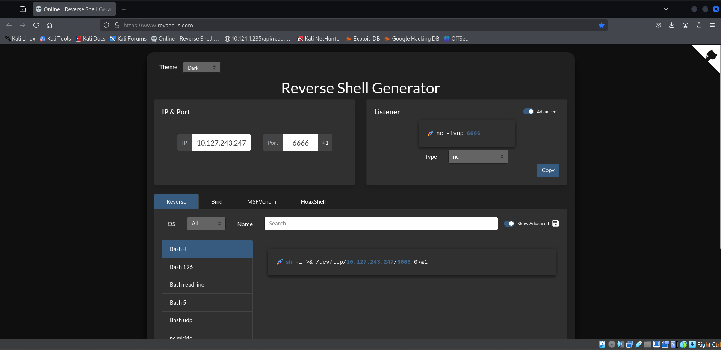
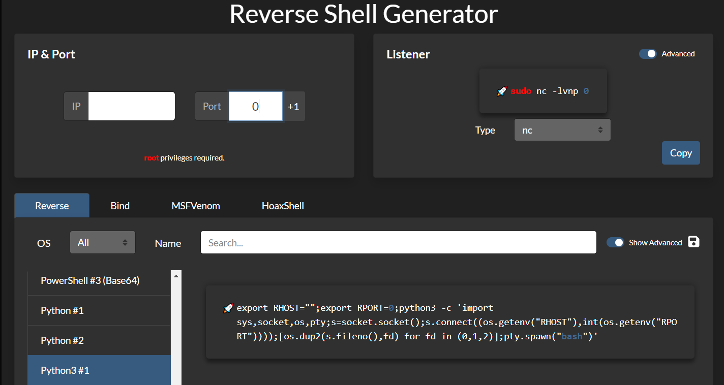
Fig. 3.48 Generating payload for reverse shell
This Figure 3.49 shows the result of using the reverse shell payload generated earlier.
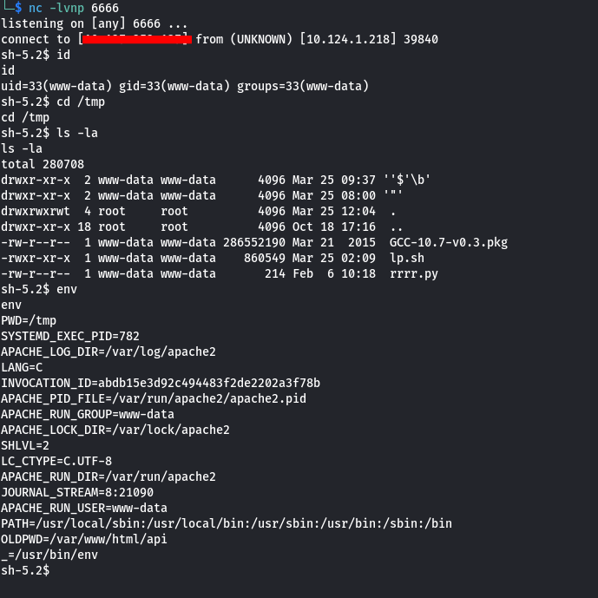
Fig. 3.49 Getting connection

Steps and Output:
- Listening: The attacker sets up a listener on port 6666 using nc -lvnp 6666.
- Connection Established: The connection is made from the victim’s machine, shown by connect to [redacted] from (UNKNOWN) [10.124.1.218].
- Commands Executed:
  - id returns user information: uid=33(www-data) gid=33(www-data) groups=33(www-data).
  - cd /tmp changes directory to /tmp.
  - ls -la lists files in /tmp.
  - env displays environment variables.
Explanation:
The attacker sets up a listener, and the reverse shell payload connects back, providing remote command-line access. The attacker can now execute commands and explore the server.
The caption Fig. 3.39 Getting connection shows the result of establishing a connection using the reverse shell payload from the previous example.

